GASTITE® CSST TECHNICAL DATA
Product description:
Gastite® CSST is a cost-effective gas piping solution that can signifcantly reduce installation time. The system offers flexibility in terms of pipe positioning and can be easily routed through complex structures. With the average installation requiring fewer fittings, (when compared to traditional piping methods), there is less leak potential, making for a safer system with reduced call backs.
Measurements:
 | OUTER DIAMETER WITH COVER | OUTER DIAMETER WITHOUT COVER | INTERNAL DIAMETER | TUBING WALL THICKNESS | COVER THICKNESS | LENGTHS AVAILABLE (M)
DN15 | 19.8 | 18.4 | 15.0 | 0.24 | 0.71 | 30, 75
DN20 | 25.7 | 24.3 | 20.0 | 0.24 | 0.71 | 30,75
DN25 | 33.3 | 31.9 | 26.3 | 0.24 | 0.71 | 30, 45, 75, 90
DN32 | 39.4 | 38.0 | 31.7 | 0.28 | 0.71 | 45, 75, 90
DN40 | 48.3 | 46.9 | 40.0 | 0.30 | 0.71 | 45, 75
DN50 | 60.3 | 58.9 | 50.2 | 0.30 | 0.71 | 45
Custom lengths also available.
Applications:
- For the supply of natural gas or liquefied petroleum gas to an appliance
- Suitable for installation in all modes of construction including residential, commercial, new build, industrial or retro-fit
- Gastite® CSST is not suitable for use as a flexible appliance connector

Fig 1.0: Gastite® CSST with XR2™ fitting
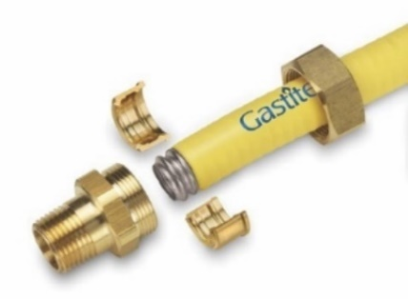
Volume:
PIPE SIZE | VOLUME OF 1M LENGTH OF GASTITE® CSST (M³)
DN15 | 0.00021
DN20 | 0.00037
DN25 | 0.00065
DN32 | 0.00094
DN40 | 0.0015
DN50 | 0.0023

Marking:
- Front:
GAS WWW.GASTITE.EU Gastite® CSST-EU-DNXX LOT/DATE CODE 00XXM GAS
- Reverse:
GAS-500mbar KITEMARK BS EN 15266 WARNING MESSAGE

Material:
- Tubing: stainless steel 1.4306-304L 10.0
- Outer jacket: UV resistant polyethylene
Characteristics:
- Flexible
- Efficient
- Easy to install
- No hot works
- Only simple hand tools required
- Gastite® CSST is fire rated/tested at 820˚ for 89 minutes under EN 1775:007 Annex A
- Minimum operating temperature: -40ºC
- Maximum operating temperature: 60ºC

Compatibility:
- For use only with XR2™ fittings with Jacket-Lock® which eliminate exposed steel beyond the nut and offer self-guiding assembly for a perfectly even flare
- Gastite® CSST can be used as the connecting interface to copper or steel
Storage:
- Gastite® CSST should be stored in a dry area until required
- Gastite® CSST should not be left outside prior to installation
- If exposed to extreme low temperature, allow to warm to room temperature before use
- Due to the potential risk of corrosion that some chemicals present to stainless steel, the piping must not be exposed to any acids, bases, salts or other caustic materials

Safety:
- All gas installation work shall be carried out by a business or self-employed operative who is a member of a class of persons approved by the Health and Safety Executive (HSE). Currently Gas Safe Register is the registration body.
Acceptable certificates of competence are those issued under the:
- Nationally Accredited Certification Scheme (ACS) for individual gas fitting operatives.
- Scottish/National Vocational Qualifications (NVQ) that have been aligned to ACS in matters of gas safety.

- CSST tube ends are sharp and care should be taken when handling.
Further information:
- More details on installation best practice can be found in Gastite® CSST Design & Installation Guide –available for download at www.gastite.co.uk/resources or by emailing info@gastite.co.uk

